**Relational Algebra**

Relational algebra is a **procedural query language** (or) **formal query language**, which takes instances of relations as input and yields instances of relations as output. It uses operators to perform queries. An operator can be either **unary** or **binary**. They accept relations as their input and yield relations as their output. Relational algebra is performed recursively on a relation and intermediate results are also considered relations.

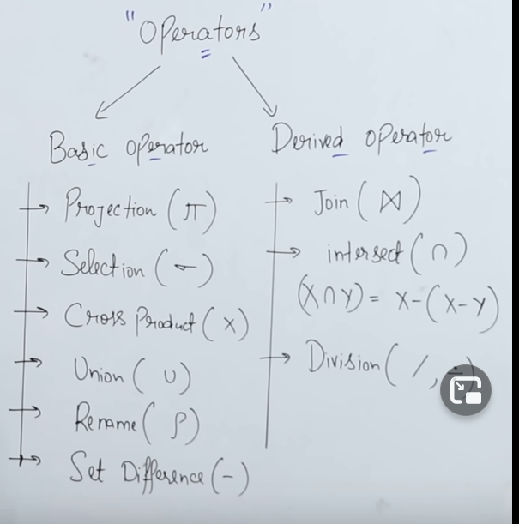

**Projection ( 🡪 Selects a particular column**

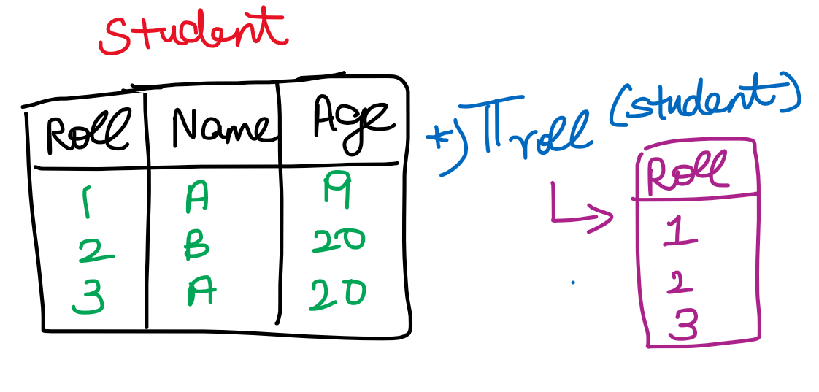

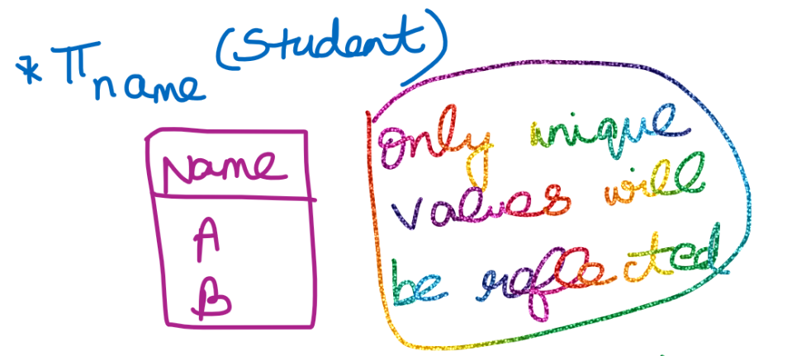

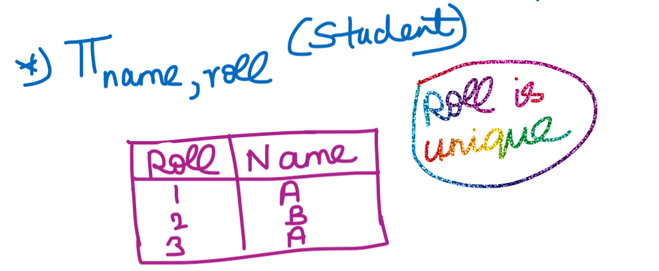

**Selection ( 🡪 Selects a particular row(tuple)**

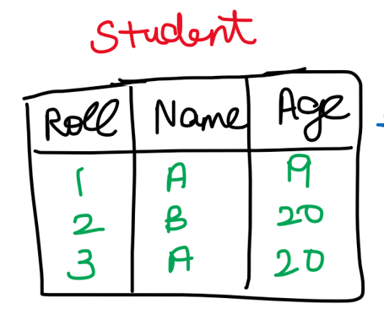

**Retrieve the name of the student whose roll no=2**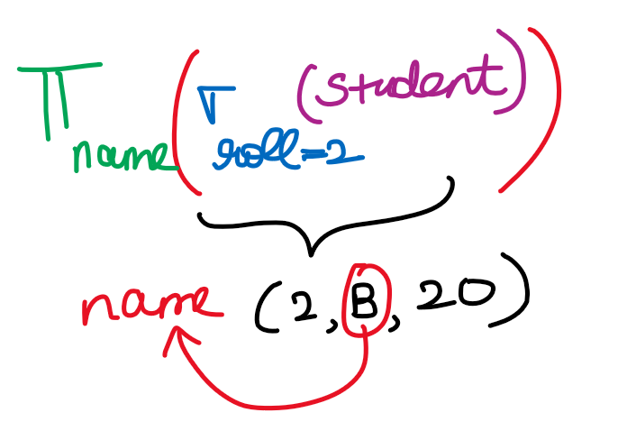

**Shifting projection and selection, what will happen ????**

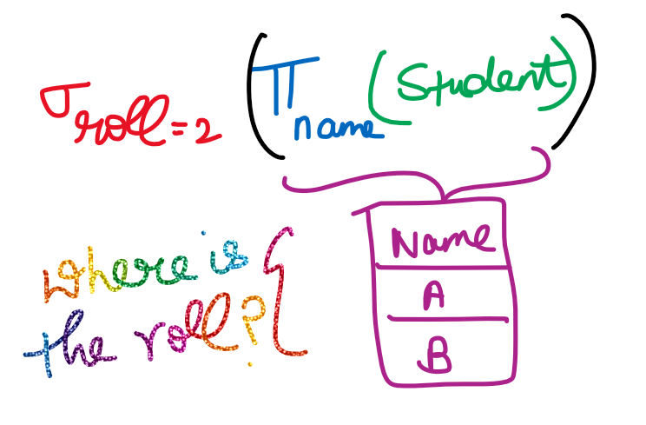

**Cross Product**

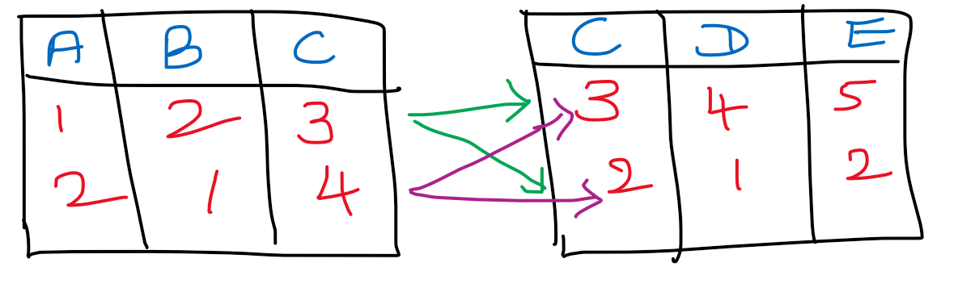

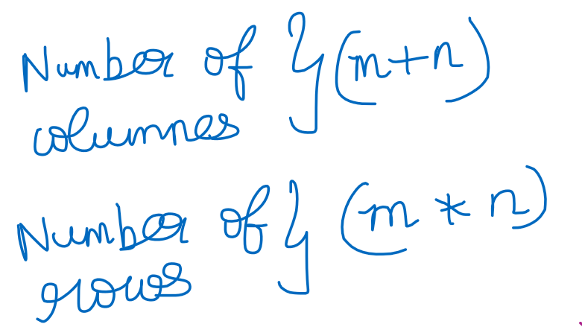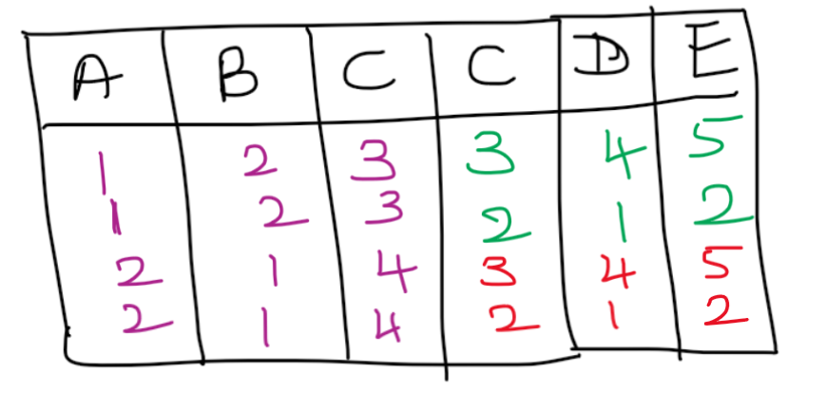

Here C column is repeated (since at-least one column should be common)

**Set Difference (-)**

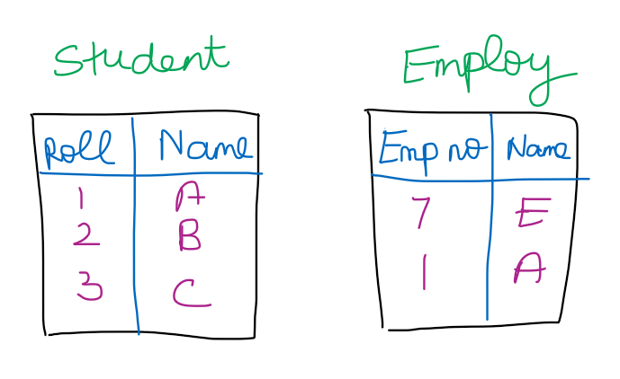

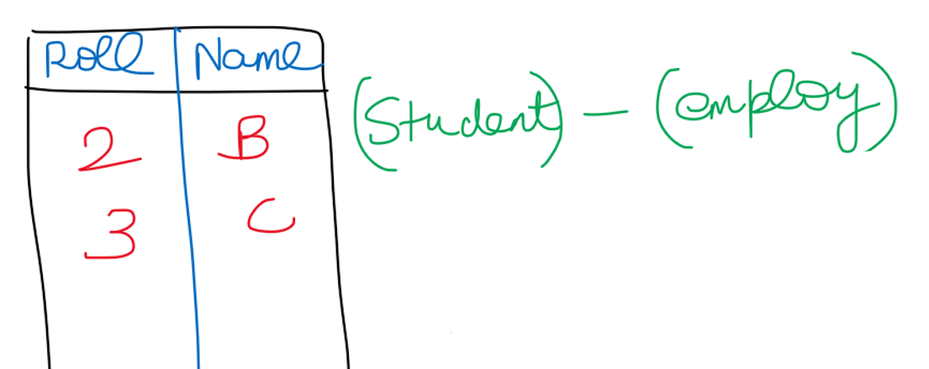

**Name of the person who is a student and but not an employ**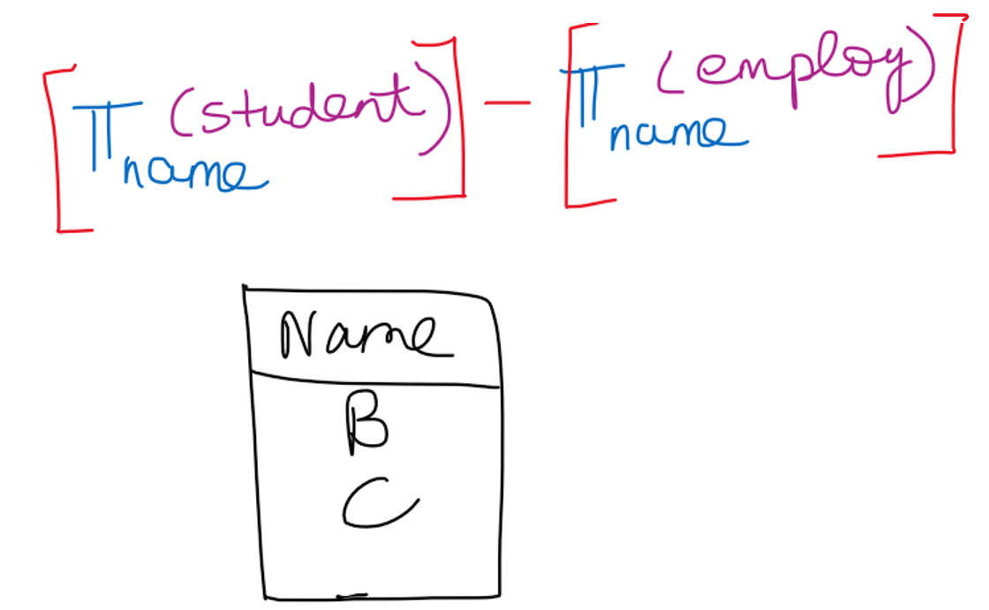

**Name of the person who is an employ and but not a student**

**Union**

Number of columns must be same.  
Domain of every column must be same.

Union operation

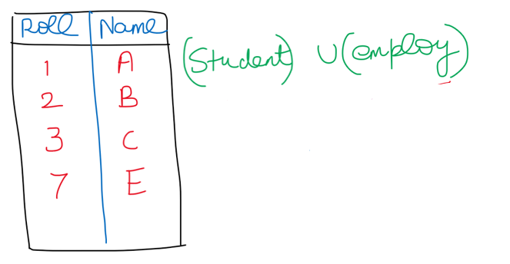



**Name of the student who is both employ and student**

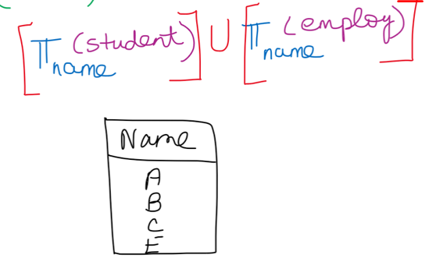

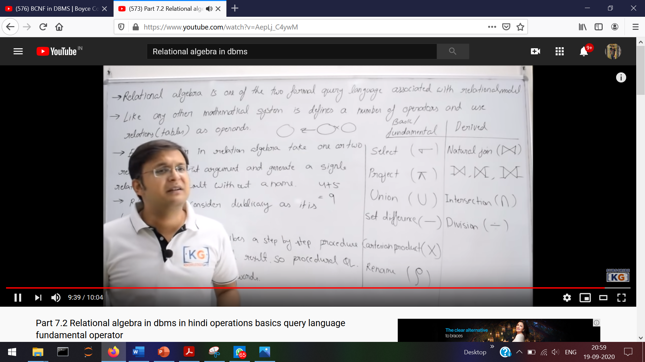

**Select**



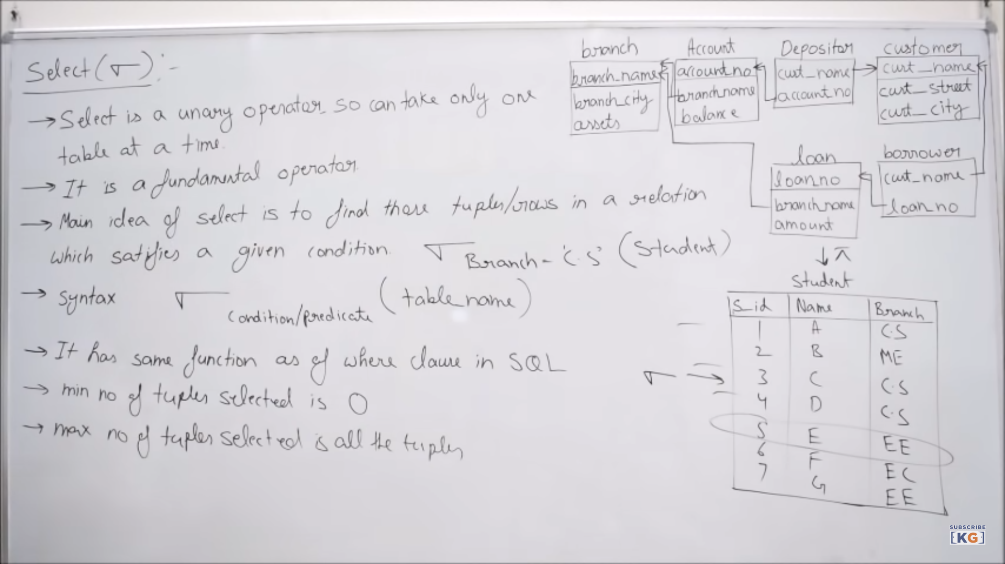



Minimum number of tuples selected 🡪 branch is ‘Civil’  
Maximum number of tuples selected 🡪 Sid <=7



**Practice question - 1**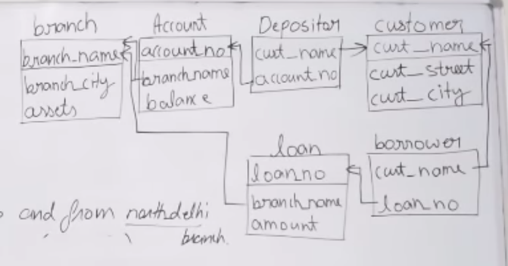

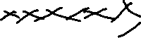

**Selection**

**Find the details of accounts having balance greater than 1000??**

Balance>=1000 (account)



**Find the details of the customer who lives in Delhi??**

customer_city=’Delhi’(customer)



**Find the details of the loans having amount<=5000 and from ‘North Delhi’ branch???**

amount<=5000 ( branch_name=’North Delhi’ (loan) )



branch_name=’North Delhi’ ( amount<=5000 (loan))



(loan)  
 branch_name=’North Delhi’ amount<=5000



**Find the branch details which are in Delhi or having assets>=10,00,000???** (branch)  
 assets>=10,00,000 branch_city=’Delhi’



**Projection   
Find all the branch names of the bank????**

(branch) [ In account and loan table ‘branch_name’ 🡪 foreign key]branch_name



**Find all the account number along with the balance???**  (account)



account_no,balance

**Find the names of all the customers who have loan??**

(borrower)  
 Customer_name



**Find all the details about the branch???**

(branch) 🡪 It includes all the attributes along with all the rows of the branch

**Selection along with projection**

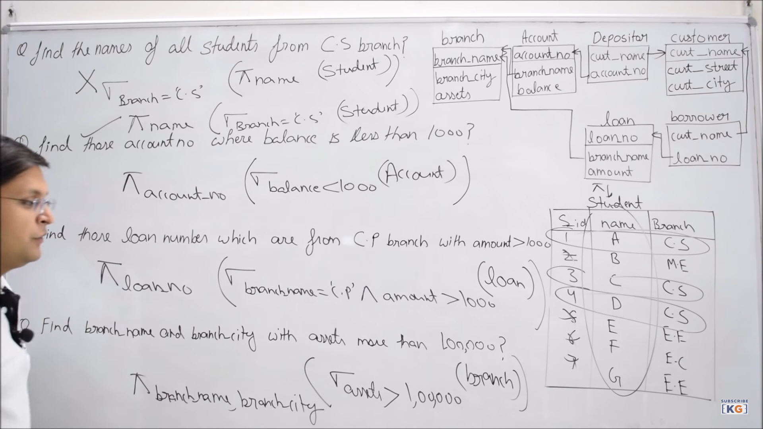

Why intersection is a derived attribute?????

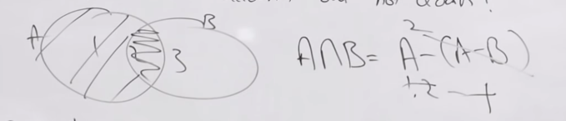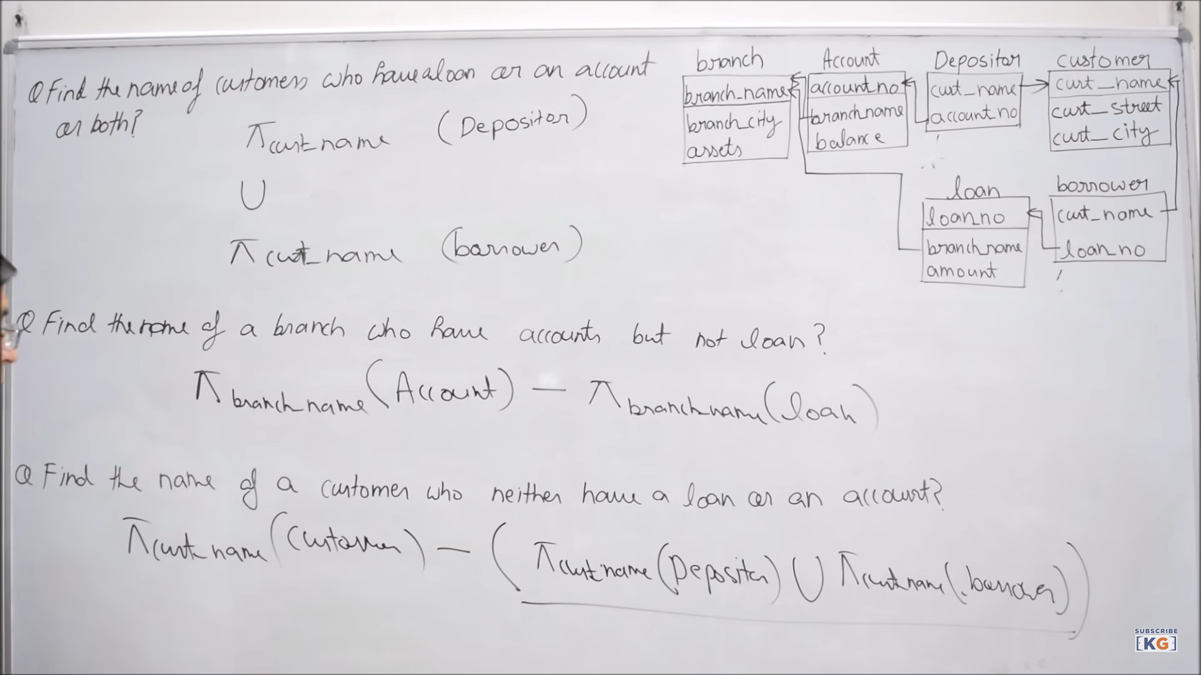

Cartesian Product  
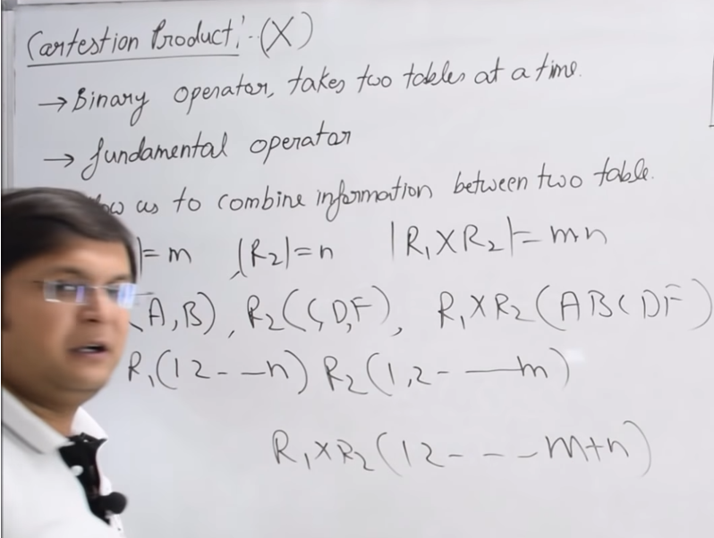  
Table

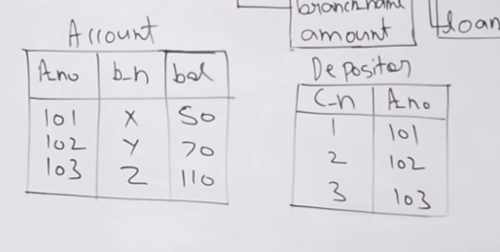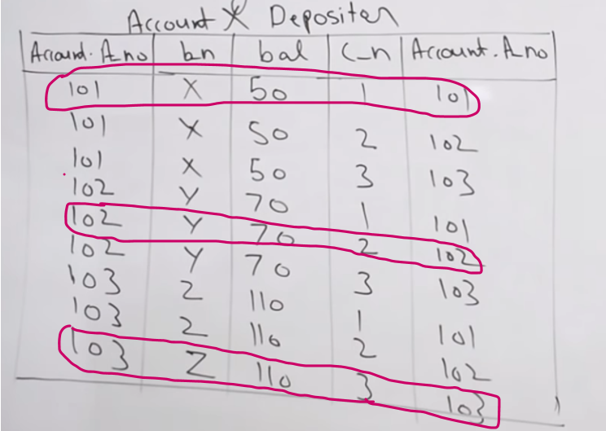  
1)Cartesian product and then removing redundant attributes by matching the common attribute.

Answer

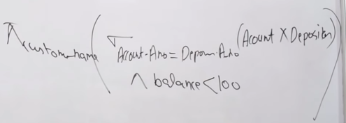

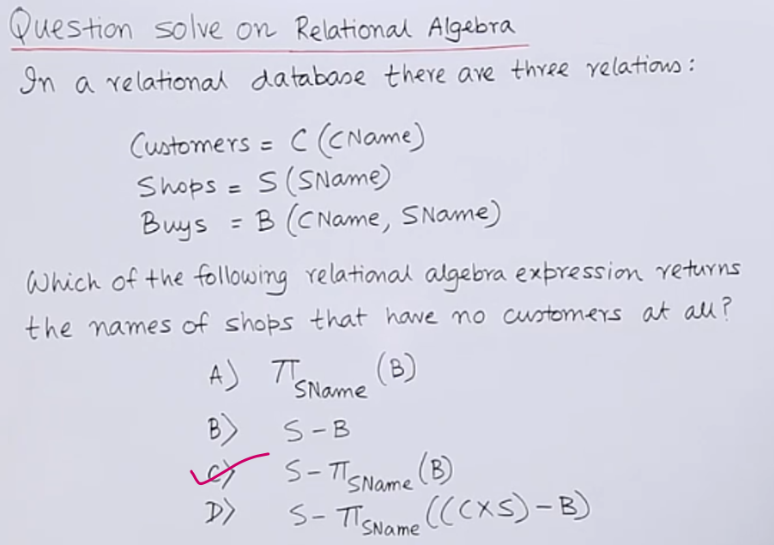

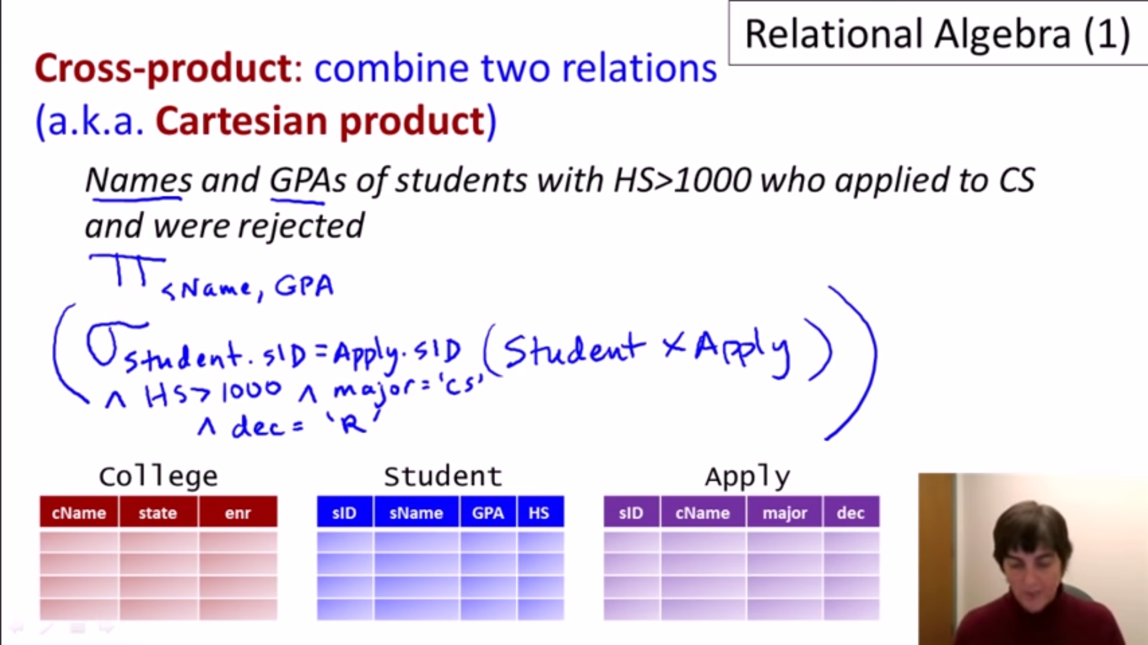  
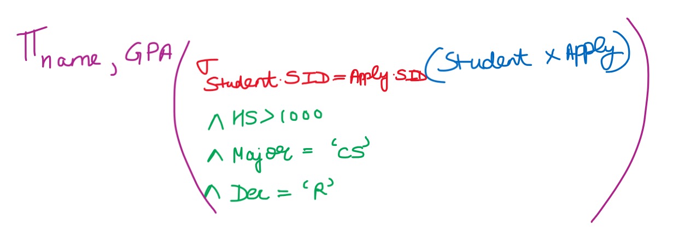

**Natural Join**

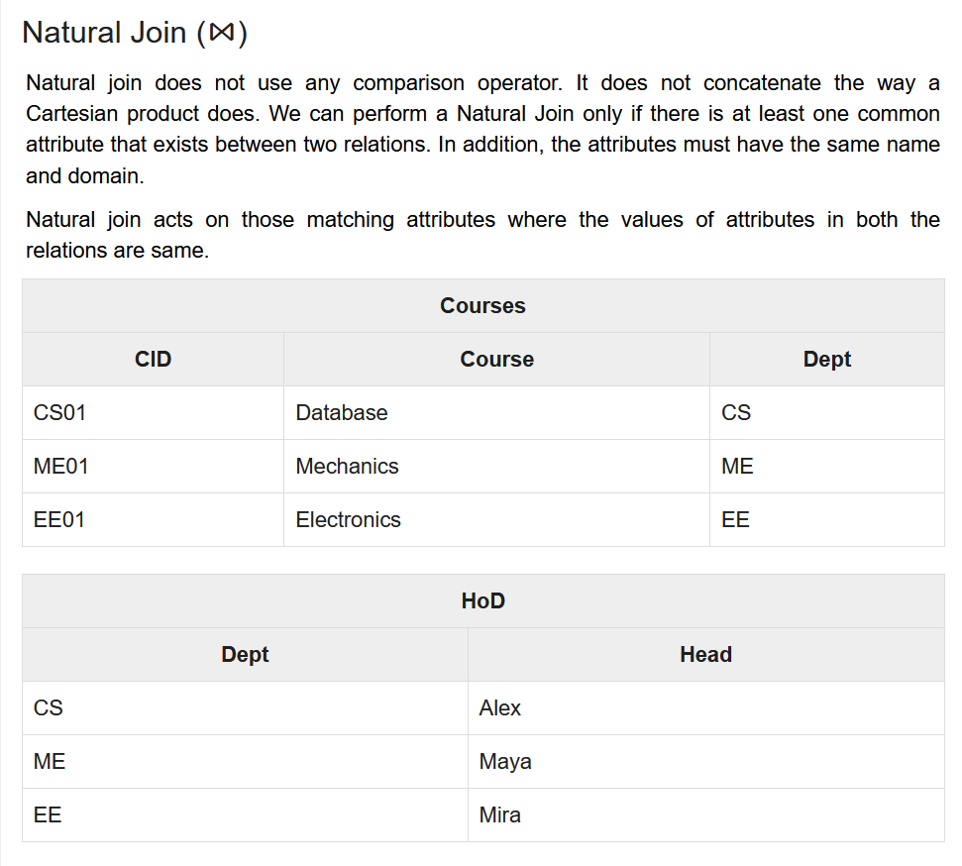  
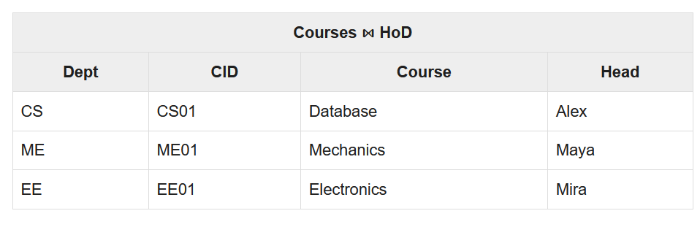

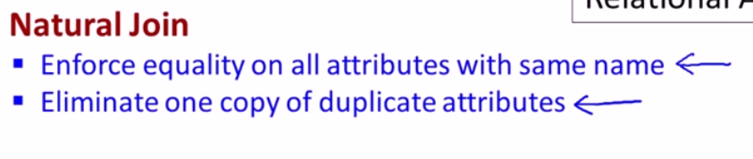  
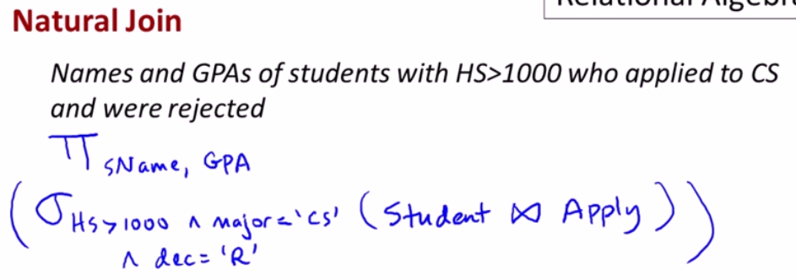  
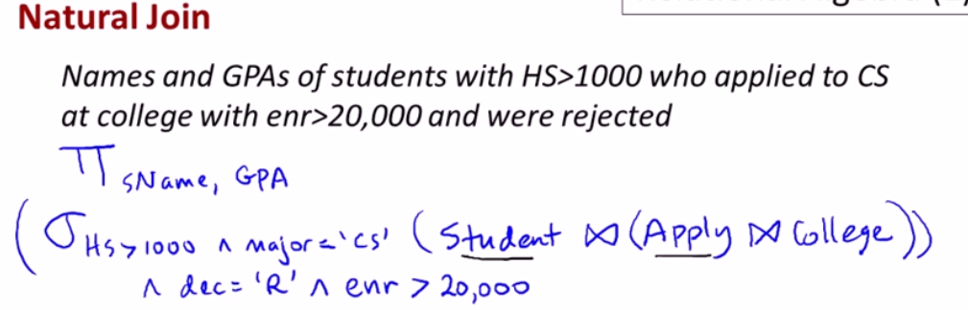

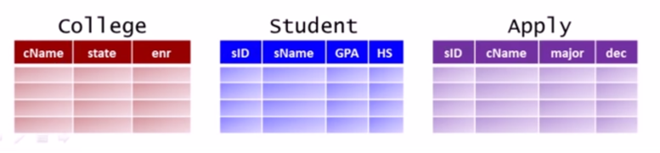  
Natural join is a binary operator So first make the natural join of (Apply and College) via **cName** and then make the natural join of (Student) and (Apply College) via **sID**

